Title: Rates of All-Cause and Cause-Specific Mortality for Subtypes of Type 2 Diabetes
Author Names: Krishna Sanaka, Jiali Guo, Daniel Hua, Zhongyu Li, Mohammed K. Ali, Jithin Sam Varghese
Author Affiliations:
1 College of Arts and Sciences, Emory University, Atlanta, GA
2 Emory Global Diabetes Research Center of the Woodruff Health Sciences Center and Emory University, Atlanta, USA.
3 Hubert Department of Global Health, Rollins School of Public Health, Emory University, Atlanta, USA
4 Nutrition and Health Sciences Doctoral Program, Laney Graduate School, Emory University, Atlanta, USA
5 Department of Family and Preventive Medicine, School of Medicine, Emory University, Atlanta, USA
Corresponding Author: Jithin Sam Varghese, Emory Global Diabetes Research Center, Woodruff Health Sciences Center, Emory University, Atlanta, GA, 30322, USA; Phone: +1 (404) 502-0415, E-mail: jvargh7@emory.edu
Short running head:
Abbreviations: T2D, Type 2 Diabetes; MARD, Mild Age-related Diabetes; MOD, Mild Obesity-related Diabetes; SIDD, Severe Insulin-Deficient Diabetes; SIRD, Severe Insulin-Resistant Diabetes

ABSTRACT
Context: Type 2 diabetes (T2D) is a heterogeneous condition with varying risks of complications and mortality. Prior studies suggest short-term differences in rates of microvascular and cardiovascular complications by subtype, but the associations of diabetes heterogeneity with premature mortality are less understood.
Objective: To assess differences in all-cause and cause-specific mortality across data-driven adult subtypes of T2D in a nationally representative sample.
Design: Cross-sectional surveys with prospective mortality linkage.
Setting: National Health and Nutrition Examination Survey (NHANES), 1999–2018.
Participants: 2,440 adults aged ≥18 years with newly diagnosed T2D (duration ≤1 year)
Exposure(s): Four subtypes of T2D defined using k-means clustering of age, BMI, HbA1c, HOMA2-%B, and HOMA2-IR: Severe Insulin Deficient Diabetes (SIDD), Severe Insulin Resistant Diabetes (SIRD), Mild Obesity-related Diabetes (MOD), and Mild Age-related Diabetes (MARD).
Main Outcome Measures: Cox Proportional Hazards for rates of all-cause and cause-specific mortality (cardiovascular, cancer, and other), determined via National Death Index linkage up to December 2019.
Results: Among the analytic sample, 52.5% were classified as MARD, 25.5% as MOD, 10.6% as SIDD, and 11.4% as SIRD. SIDD had the highest HbA1c and lowest beta-cell function, while SIRD had the highest insulin resistance. MARD was associated with the highest crude rates of mortality. However, after adjustment for age, sex, smoking, and calendar decade, there were no significant differences in mortality across subtypes.
Conclusions: Despite substantial clinical differences, T2D subtypes did not differ in long-term all-cause or cause-specific mortality. These findings may reflect improved chronic and acute care, including modern antihyperglycemic and cardioprotective therapies. Future research should examine whether underlying mortality pathways differ by subtype and explore opportunities for targeted prevention.
KEYWORDS: precision medicine, diabetes phenotypes, clusters, beta cell function, insulin deficiency, insulin resistance
Introduction
Type 2 diabetes (T2D) is a heterogeneous disease, with 1.2 million individuals newly diagnosed annually in the United States. Individuals with T2D vary in their responses to glucose-lowering medications and are at varying risk of severe complications (1,2). Precision medicine aims to identify groups of individuals who share clinical or genetic characteristics, with the goal of tailoring treatment beyond a one-size-fits-all approach (3,4). The most widely replicated precision medicine approach for diabetes involves four subtypes of newly diagnosed T2D, namely Severe Insulin Deficient Diabetes (SIDD), Severe Insulin Resistant Diabetes (SIRD), Mild Obesity-related Diabetes (MOD), and Mild Age-related Diabetes (MARD) (1,5). Findings from diverse cohort studies and large-scale electronic health records replicating this subtyping framework suggest elevated short-term rates of microvascular and cardiovascular complications for SIDD and SIRD, relative to the other subtypes (5–7). However, long-term outcomes across T2D subtypes, such as premature mortality, have not yet been assessed due to the limited duration of study follow-up in cohort studies and electronic health records (8).
Premature mortality from T2D has declined since the 1990s, largely due to an absolute and relative reduction in cardiovascular mortality, which currently accounts for four out of 10 deaths from diabetes (9). This decrease is primarily driven by better pharmacological and lifestyle management of vascular risk factors and improvements in acute care. Meanwhile, the relative burden of premature cancer mortality has remained stagnant over the period (two out of 10 deaths), with similar rates of decline among individuals with and without diabetes (9). There is a critical need to study whether different subtypes of T2D vary in their risk of mortality from cancer and cardiovascular disease to inform prevention and early detection strategies.
Using nationally representative surveys linked to mortality data from the United States, our objective is to examine differences among T2D subtypes in all-cause and cause-specific mortality rates. The findings from this study can inform the development of long-term prevention strategies and public health policies tailored to these subtypes, aimed at reducing premature mortality among populations affected by type 2 diabetes.
Materials and Methods
Study Population
Data for this study were obtained from 11 rounds of the National Health and Nutrition Examination Survey (NHANES 1999-2018), which are conducted biennially by the National Center for Health Statistics (NCHS). NHANES is a nationally representative survey of the noninstitutionalized civilian population in the United States. The survey includes an in-home interview to gather information on demographics, socioeconomic factors, and lifestyle, followed by a physical examination incorporating a dietary interview, medical assessments, and laboratory tests. All examinations are conducted by trained medical staff at a mobile examination center. All participants of NHANES provided written informed consent.
We identified 2,537 adults aged 18 years with recently diagnosed T2D (duration ≤1 year) based on self-reports or probable undiagnosed T2D indicated by elevated laboratory biomarkers, as discussed below. Participants with pre-existing diabetes (duration > 1 year) were excluded. After removing those for whom BMI and HbA1c data were unavailable, our final analytic sample consisted of 2,440 participants (Supplementary Figure 1).
Data collection and variable specification
Newly Diagnosed Diabetes
Newly diagnosed T2D were identified based on self-reported responses to the following questions: “Other than during pregnancy, have you ever been told by a doctor or health professional that you have diabetes?” and “How old were you when a doctor or other health professional first told you that you had diabetes?”. We additionally included undiagnosed T2D who were defined as no self-reported diabetes and at least one of HbA1c ≥6.5% or fasting plasma glucose (FPG) ≥126 mg/dL (if available) (12).
Clustering Variables
In the comprehensive physical examination, anthropometry and laboratory samples were collected (13). Consistent with previous subtyping studies, we used five variables obtained at T2D diagnosis: age, body mass index (BMI), HbA1c, and homeostatic indices of beta-cell function (HOMA2-%B) and insulin resistance (HOMA2-IR) (5). HbA1c, FPG, and fasting insulin were determined using the Tosoh G8 Glycohemoglobin Analyzer, Roche/Hitachi Cobas C Chemistry Analyzer – C311 and Tosoh Bioscience AIA-900, respectively. Homeostatic indices were calculated using the Oxford HOMA2 model, which accounts for the nonlinear relationship between insulin and FPG in the body, therefore providing a more accurate assessment of glucose metabolism compared to the original HOMA model (14,15).
Covariates
In addition to the clustering variables, we extracted socio-demographic, anthropometric, and laboratory measures from NHANES public-use files. Socio-demographic variables included sex, race and ethnicity, insurance, and household income. Anthropometric measures included body composition (whole body and regional fat percentages for trunk, arm and legs, and lean mass), waist circumference, and blood pressure. Laboratory measures included lipids (LDL, HDL, and triglycerides), renal function (estimated glomerular filtration rate [eGFR] based on CKD-EPI 2021 equations), and liver function tests (alanine aminotransferase [ALT], aspartate aminotransferase [AST]) (16).
Outcome: Mortality
Mortality status was determined using the public-use files that link the NHANES participants with the National Death Index (NDI), for whom information on causes of death and time since examination until death were available up to December 31, 2019 (17). Primary cause of death was identified for each individual, using the International Classification of Diseases, 10th Revision: Underlying Cause of Death Recode, and subsequently classified into broad diagnostic categories such as heart diseases and malignant neoplasms (18). We categorized causes of mortality into three groups: cardiovascular diseases, cancers, and other causes.
Statistical Analysis
Data-driven clustering
We used k-means cluster analysis and explored the optimal number of clusters ranging from 2 to 10. The optimal number was identified by combining results from an elbow plot with considerations of clinically meaningful clusters and adequate sample sizes (19). Consistent with previous studies, k-means clustering did not provide separable clusters of T2D, meaning that there was some overlap in the clinical features of the subgroups (5,20). Therefore, we opted for four clusters for defining subtypes within the analytic sample (Supplementary Figure 2). Since nearly 40% of the analytic sample were missing FPG and fasting insulin (Supplementary Table 1), we used clustering variables along with relevant auxiliary variables (e.g., LDL, HDL, triglycerides, ALT, AST, eGFR, SBP, DBP, and waist circumference) to single impute missing FPG and fasting insulin data using the k-nearest neighbors algorithm (k = 4) (21). Similar machine learning approaches were previously shown to be successful for imputing missing data before T2D subtyping (22).
We examined clinical characteristics across the clusters to guide our labeling of these subtypes as MOD, MARD, SIDD, and SIRD (5). Previous studies did not suggest differences in those clinical characteristics by sex, and hence, sex specific analyses were not conducted. Cluster stability across survey rounds was assessed using boxplots and the Adjusted Rand Index (ARI). The ARI measures agreement between clusters, correcting for chance, with values close to 1 indicating perfect overlap and values near 0 indicating random chance (23). We considered an ARI value of 0.9 or greater as “stable” in this study, consistent with previous consensus (24).
Survival analysis
We first used Kaplan-Meier estimators to describe survival probabilities and visualize differences in all-cause and cause-specific mortality (cardiovascular mortality, cancer mortality, and all other causes) across T2D subtypes. Participants without a recorded cause of death were censored at the last known follow-up date (December 31, 2019). For two individuals without recorded follow-up mortality information, censoring was imputed using the median interview date of their survey cycle.
To evaluate whether individuals with varied T2D subtypes experience different rates of premature mortality, proportional hazards assumptions were not violated based on Schoenfeld residuals (Supplementary File 2). Therefore, we fit Cox Proportional Hazards regression models to study the relative rates for subtypes with five-year, ten-year, and overall all-cause mortality. We conducted exploratory analyses for cause-specific mortality given the low frequency of events. We estimated both unadjusted and adjusted Cox models. The adjusted models were controlled for age, sex, smoking status, and calendar decade (modeled as fixed effects). All analyses accounted for the complex survey design and incorporated sampling weights provided by the National Center for Health Statistics (NCHS).
We conducted different sensitivity analyses to assess the robustness of our findings. First, we studied the relative rates among subtypes of diabetes identified using the five clustering variables and including those with duration of diagnosis >1 year. We adjusted for medication use for diabetes, high blood pressure, and high cholesterol. Second, we ignored the complex survey design to study unweighted rates. Finally, we compared the relative rates of all-cause and cause-specific mortality to adults who were 40 years or older without T2D, serving as a reference group. The analyses were conducted using the Scikit-learn and survival packages in Python 3.12.4 and R 4.1.2, respectively.

Results
The final analytic sample consisted of 2,440 participants, who were representative of 7,566,885 individuals with newly diagnosed T2D in the United States. On average, participants were 55.8 (95% CI: 55.0-56.5) years old, 54.3% (95% CI: 51.4-57.2) were male, 58.6% (95% CI: 54.9-62.1) were Non-Hispanic White, 82.6% (95% CI: 80.4, 84.5) had health insurance, and 18.9% (95% CI: 17.0, 20.9) reported annual household incomes below $20,000. Participants excluded due to missing BMI or HbA1c (n = 97) were more likely to be female, older, and insured than participants with these assessments (Supplementary Table 2).
There were noticeable differences in demographic and clinical characteristics across T2D subtypes (Table 1). MOD had the highest BMI (39.6 kg/m² [SD: 7.4]) and MARD had the highest average age of T2D diagnosis (62.7 years [SD: 13.2]). Individuals classified as SIDD had the highest HbA1c (10.8% [SD: 1.6]) and lowest HOMA2-%B (49.5 [SD: 32.1]). SIDD also had the highest levels of LDL cholesterol (125.8 mg/dL [SD: 31.4]) and triglycerides (229.7 mg/dL [SD: 150.9]) compared with other subtypes. Meanwhile, individuals classified as SIRD showed high HOMA2-IR (6.0 [SD: 1.8]) and intermediate BMI (36.0 kg/m² [SD: 9.2]). Cluster stability, as measured by the Adjusted Rand Index (ARI), exceeded 0.94 in all but two cycles: 2005–2006 (ARI: 0.47) and 2007–2008 (ARI: 0.49), indicating reduced consistency in subtype assignment during those years (Supplementary Table 3).
A visualization of the distribution of clustering variables is presented in Figure 1. While subtypes showed overlapping distributions for most input variables, distinct separation was evident for defining features of each group, such as BMI for MOD, age for MARD, HOMA2-IR for SIRD, and HbA1c and HOMA2-B for SIDD. Supplementary analyses of body composition patterns further supported the distinctiveness of subtypes (Supplementary Table 4). MOD and SIRD demonstrated the highest whole-body fat percentage (41.2% [95% CI: 40.3% – 42.1%] and 37% [95% CI: 38.5% – 35.5%], respectively) and central adiposity, with elevated trunk fat % (42.2% [95% CI: 41.2% – 43.3%] and 38.4% [95% CI: 36.6% – 40.2%], respectively), waist circumference (122.8 [95% CI: 121.2 – 124.4] cm and 116.8 [95% CI: 112.9 – 120.7] cm, respectively), and trunk-to-limb fat ratios (0.260 [95% CI: 0.255 – 0.264] and 0.271 [95% CI: 0.260 – 0.282], respectively), consistent with adiposity- and insulin resistance–driven diabetes. In contrast, MARD exhibited the lowest lean mass index (LMI) and total lean mass, reflective of possible age-related sarcopenia. SIDD also showed lower LMI and lean mass as well as low % trunk fat and % subcutaneous fat, suggesting a leaner, insulin-deficient phenotype.
Unadjusted analyses showed that individuals with SIDD, SIRD, and MOD had significantly lower all-cause mortality rates compared to MARD, which likely reflects the older age of individuals in the MARD group (Figure 2). For example, unadjusted 10-year all-cause mortality was 0.50 (95% CI: 0.33–0.85) for SIDD and 0.29 (0.19–0.45) for MOD, compared to the reference MARD group. Similar patterns were observed for cause-specific mortality, with MARD having the highest unadjusted mortality (xx, [x, x]) from cardiovascular and cancer causes (Table 2). However, after adjusting for age, sex, smoking, and calendar decade, these differences were attenuated across all subtypes, and confidence intervals widened substantially—particularly for cardiovascular and cancer mortality—indicating limited precision due to fewer events in these subgroups.
Sensitivity analyses yielded consistent findings. Results were similar when we ignored the complex survey design (Supplementary Table 5) and when we included all individuals with diabetes—regardless of diagnosis duration—while adjusting for medication use for diabetes, hypertension, and hyperlipidemia (Supplementary Table 6). Subtype classifications were stable across most survey cycles. Relative to participants without T2D, all subtypes had higher all-cause and cause-specific hazards of mortality (Supplementary Figure 3, Supplementary Table 7).
Discussion
In this nationally representative study of U.S. adults with newly diagnosed type 2 diabetes (T2D), we observed that long-term all-cause and cause-specific mortality rates were similar across the four commonly reported subtypes—MARD, MOD, SIDD, and SIRD. While unadjusted analyses showed higher mortality in the MARD group, these differences largely attenuated after adjusting for socio-demographic covariates. These findings were robust across multiple sensitivity analyses, including models that incorporated prevalent diabetes cases and those that did not account for complex survey design.
The distinct demographic and clinical characteristics across subtypes align with those previously reported globally in diverse populations (5,25–27). We observed notable clinical differences across subtypes, such as higher HbA1c and lower beta-cell function in SIDD, and elevated insulin resistance in SIRD. However, these subtype-defining characteristics did not translate into long-term differences in premature mortality risk over the follow-up period.
There are several potential explanations for the divergence between the findings of our study on T2D mortality and those of previous studies that have primarily reported subtype-specific differences in diabetes related complications. First, our analysis leveraged a nationally representative survey sample, which may offer a more accurate reflection of mortality risk across the general population with T2D, compared to high-risk or clinic-based cohorts often used in previous research (28). Second, diabetes-related mortality—particularly from cardiovascular disease—has declined substantially in the United States over the recent decade (29). These reductions are likely mediated by improved primary and secondary prevention from long-term behavioral and multidrug therapies for diabetes patients (30,31). In particular, newer pharmacological agents such as sodium-glucose cotransporter-2 (SGLT2) inhibitors and glucagon-like peptide-1 (GLP-1) receptor agonists as well as higher rates of statin and antihypertensive treatment may have significantly lowered risk of cardiovascular mortality among individuals with T2D (32–35). The increased uptake of these therapies in the past decade, especially among those at highest risk of cardiovascular disease, may have helped attenuate mortality differences that might have otherwise emerged between subtypes.
Nevertheless, our null findings in premature mortality do not contradict earlier studies that reported higher risks of microvascular and macrovascular complications in the SIDD and SIRD subtypes compared to MOD and MARD (5,36). Rather, they suggest that while subtypes may differ in early clinical course or complication rates and potentially quality of life, these differences do not necessarily translate into disparities in long-term survival—particularly within a healthcare landscape marked by improved chronic disease management.
In addition, advancements in the acute management of diabetes-related emergencies may also have contributed to the convergence in mortality risk across subtypes. Over the past two decades, emergency care for complications such as hyperglycemia, diabetic ketoacidosis, and cardiovascular events has markedly improved through enhanced triage protocols, earlier therapeutic interventions (e.g., insulin and fluid administration), and greater access to cardioprotective agents (37,38). Correspondingly, declines in hospital mortality from hyperglycemic crises, diabetic ketoacidosis, and heart failure have been well documented (39–42). These systemic improvements in acute care likely mitigate fatal outcomes irrespective of underlying T2D subtype.
Lastly, the absence of subtype differences in cancer-related mortality—despite variation in baseline HbA1c and BMI—may reflect the multifactorial nature of cancer progression. HbA1c, a marker of short- to medium-term glycemic control, may not fully capture long-term metabolic disturbances relevant to cancer development. Moreover, cancer prognosis is heavily influenced by tumor biology, stage at diagnosis, and access to timely treatment—factors that may not systematically vary by glycemic status at the time of T2D diagnosis (43). Similarly, the impact of BMI-based obesity on cancer mortality may be attenuated once cancer is established, particularly in the presence of modern oncological care (44). Additionally, BMI is an imperfect proxy for adiposity and fat distribution, and may not capture visceral or ectopic fat, which have been more strongly implicated in disease progression (45). Besides, the increasing availability of effective cancer therapies may further diminish the influence of adiposity on survival outcomes once cancer has been diagnosed.
Strengths of this study include the usage of nationally representative survey data with comprehensive biometric examinations linked to death records. NDI data, encompassing over 115 million death records from 1979 onwards, enabled precise linkage and classification of outcomes for this study (46). The use of NHANES enhances the robustness of our findings and supports generalizability to the adult population in the United States. Furthermore, this study addresses an important gap in existing literature by highlighting similarities in cause-specific mortality across T2D subtypes.
The present study has several limitations. First, although we linked NHANES data to the NDI for longitudinal analysis, the lack of continuous follow-up data on variables such as lifestyle changes and evolving comorbidities hinders our understanding of differences in mediating pathways to mortality. Second, the k-means clustering approach used to identify subtypes, while widely applied in diabetes research, may not fully capture the complexity of diabetes due to its reliance on predefined distance measures and assumption of spherical clusters (47). This limitation may lead to overlapping or misclassified subtypes, potentially influencing the observed mortality associations. Despite advantages such as ease of communication and opportunities for hypothesis generation from hard clustering (48), we note that risk scores based on continuous clinical features may be more useful for predicting disease progression (1). Third, although our sample size met the heuristic criteria for adequate power (≥20 events [deaths] per variable) for the all-cause and cause-specific models (49), such heuristics are based on non-probabilistic samples. Therefore, our analyses may have been underpowered to detect differences between subtypes in rates of mortality. However, our analysis of all individuals with T2D reported similar findings, suggesting that age-adjusted subtype membership is not prognostic of mortality. Finally, we were unable to distinguish between T2D other less common phenotypes of diabetes in our sample.
This study highlights that long-term mortality rates appear similar across T2D subtypes, which may suggest the broad effectiveness of the current standards of diabetes care in improving patient outcomes. Nonetheless, the underlying pathways leading to mortality may differ across subtypes. Prior research has consistently identified higher rates of microvascular complications among individuals with SIDD and SIRD compared to those with MOD and MARD, suggesting opportunities to tailor prevention and management strategies. Future research should validate these findings in diverse populations, explore how pharmacological treatments modify subtype-specific outcomes, and integrate additional biomarkers to refine diabetes subphenotyping, ultimately advancing precision medicine and improving outcomes for people with T2D.

Ethics approval and consent to participate: All participants gave written informed consent before participation. We were exempt from ethical approval for this secondary data analysis by the Institutional Review Board of Emory University.
Data availability statement: National Health and Nutrition Examination Survey and National Death Index linkage files are available to download from the website of the Centers for Disease Control and Prevention. The code for the analysis is available on https://github.com/jvargh7/nhanes_ckm.
Conflicts of interest: All authors declare no conflicts of interest.
Funding: Research reported in this publication was supported by the National Institute of Diabetes and Digestive and Kidney Diseases of the National Institutes of Health under Award Number P30DK111024. The content is solely the responsibility of the authors and does not necessarily represent the official views of the National Institutes of Health.
Author contributions: JSV, ZL, and KOS conceptualized the study with inputs from JG and MKA. JSV and MKA designed the analysis plan. KOS and JSV conducted the analysis with inputs from JG and wrote the first draft. All authors reviewed subsequent drafts.
Acknowledgements: We thank the participants and enumerators of the National Health and Nutrition Examination Surveys 1999-2018.

References
1. Dennis JM, Shields BM, Henley WE, Jones AG, Hattersley AT. Disease progression and treatment response in data-driven subgroups of type 2 diabetes compared with models based on simple clinical features: an analysis using clinical trial data. The Lancet Diabetes & Endocrinology. 2019 Jun;7(6):442–51.
2. Udler M, Smith K, Deutsch A, McGrail C, Kim H, Hsu S, et al. Multi-ancestry Polygenic Mechanisms of Type 2 Diabetes Elucidate Disease Processes and Clinical Heterogeneity [Internet]. 2023 [cited 2024 Oct 22]. Available from: https://www.researchsquare.com/article/rs-3399145/v1
3. Chung WK, Erion K, Florez JC, Hattersley AT, Hivert MF, Lee CG, et al. Precision Medicine in Diabetes: A Consensus Report From the American Diabetes Association (ADA) and the European Association for the Study of Diabetes (EASD). Diabetes Care. 2020 Jul 1;43(7):1617–35.
4. Tobias DK, Merino J, Ahmad A, Aiken C, Benham JL, Bodhini D, et al. Second international consensus report on gaps and opportunities for the clinical translation of precision diabetes medicine. Nat Med. 2023 Oct;29(10):2438–57.
5. Ahlqvist E, Storm P, Käräjämäki A, Martinell M, Dorkhan M, Carlsson A, et al. Novel subgroups of adult-onset diabetes and their association with outcomes: a data-driven cluster analysis of six variables. The Lancet Diabetes & Endocrinology. 2018 May;6(5):361–9.
6. Pigeyre M, Hess S, Gomez MF, Asplund O, Groop L, Paré G, et al. Validation of the classification for type 2 diabetes into five subgroups: a report from the ORIGIN trial. Diabetologia. 2022 Jan;65(1):206–15.
7. Wang J, Gao B, Wang J, Liu W, Yuan W, Chai Y, et al. Identifying subtypes of type 2 diabetes mellitus based on real-world electronic medical record data in China. Diabetes Research and Clinical Practice. 2024 Nov;217:111872.
8. Misra S, Wagner R, Ozkan B, Schön M, Sevilla-Gonzalez M, Prystupa K, et al. Precision subclassification of type 2 diabetes: a systematic review. Commun Med. 2023 Oct 5;3(1):138.
9. Gregg EW, Cheng YJ, Srinivasan M, Lin J, Geiss LS, Albright AL, et al. Trends in cause-specific mortality among adults with and without diagnosed diabetes in the USA: an epidemiological analysis of linked national survey and vital statistics data. The Lancet. 2018 Jun;391(10138):2430–40.
10. Terry AL, Chiappa MM, McAllister J, Woodwell DA, Graber JE. Plan and Operations of the National Health and Nutrition Examination Survey, August 2021-August 2023. Vital Health Stat 1. 2024 May;(66):1–21.
11. Akinbami LJ, Chen TC, Davy O, Ogden CL, Fink S, Clark J, et al. National Health and Nutrition Examination Survey, 2017-March 2020 Prepandemic File: Sample Design, Estimation, and Analytic Guidelines. Vital Health Stat 1. 2022 May;(190):1–36.
12. American Diabetes Association Professional Practice Committee, ElSayed NA, Aleppo G, Bannuru RR, Bruemmer D, Collins BS, et al. 2. Diagnosis and Classification of Diabetes: Standards of Care in Diabetes—2024. Diabetes Care. 2024 Jan 1;47(Supplement_1):S20–42.
13. National Center for Health Statistics. 2020 Interviewer Procedures Manual [Internet]. Centers for Disease Control and Prevention; 2020 [cited 2024 Nov 14]. Available from: https://wwwn.cdc.gov/nchs/data/nhanes/2019-2020/manuals/2020-Interviewer-Procedures-Manual-508.pdf
14. Song YS, Hwang YC, Ahn HY, Park CY. Comparison of the Usefulness of the Updated Homeostasis Model Assessment (HOMA2) with the Original HOMA1 in the Prediction of Type 2 Diabetes Mellitus in Koreans. Diabetes Metab J. 2016;40(4):318.
15. Levy JC, Matthews DR, Hermans MP. HOMA2 Calculator [Internet]. University of Oxford, Diabetes Trial Unit; 1998. Available from: https://www.dtu.ox.ac.uk/homacalculator/
16. Inker LA, Eneanya ND, Coresh J, Tighiouart H, Wang D, Sang Y, et al. New Creatinine- and Cystatin C–Based Equations to Estimate GFR without Race. N Engl J Med. 2021 Nov 4;385(19):1737–49.
17. National Center for Health Statistics. Public-use Linked Mortality Files [Internet]. 2022 [cited 2025 May 19]. Available from: https://www.cdc.gov/nchs/data/datalinkage/public-use-linked-mortality-file-description.pdf
18. National Center for Health Statistics. Underlying and Multiple Cause of Death Codes. Data Linkage. 2018 Jan 3;
19. Nguyen LH, Holmes S. Ten quick tips for effective dimensionality reduction. Ouellette F, editor. PLoS Comput Biol. 2019 Jun 20;15(6):e1006907.
20. Aoki Y, Hamrén B, Clegg LE, Stahre C, Bhatt DL, Raz I, et al. Assessing reproducibility and utility of clustering of patients with type 2 diabetes and established CV disease (SAVOR -TIMI 53 trial). Nakazone MA, editor. PLoS ONE. 2021 Nov 19;16(11):e0259372.
21. Beretta L, Santaniello A. Nearest neighbor imputation algorithms: a critical evaluation. BMC Medical Informatics and Decision Making. 2016 Jul 25;16(3):74.
22. Tanabe H, Sato M, Miyake A, Shimajiri Y, Ojima T, Narita A, et al. Machine learning-based reproducible prediction of type 2 diabetes subtypes. Diabetologia. 2024 Nov;67(11):2446–58.
23. Warrens MJ, Van Der Hoef H. Understanding the Adjusted Rand Index and Other Partition Comparison Indices Based on Counting Object Pairs. J Classif. 2022 Nov;39(3):487–509.
24. Liu T, Yu H, Blair RH. Stability estimation for unsupervised clustering: A review. Wiley Interdiscip Rev Comput Stat. 2022;14(6):e1575.
25. Zou X, Zhou X, Zhu Z, Ji L. Novel subgroups of patients with adult-onset diabetes in Chinese and US populations. The Lancet Diabetes & Endocrinology. 2019 Jan;7(1):9–11.
26. Antonio-Villa NE, Fernández-Chirino L, Vargas-Vázquez A, Fermín-Martínez CA, Aguilar-Salinas CA, Bello-Chavolla OY. Prevalence Trends of Diabetes Subgroups in the United States: A Data-driven Analysis Spanning Three Decades From NHANES (1988-2018). The Journal of Clinical Endocrinology & Metabolism. 2022 Feb 17;107(3):735–42.
27. Varghese JS, Narayan KMV. Ethnic differences between Asians and non-Asians in clustering-based phenotype classification of adult-onset diabetes mellitus: A systematic narrative review. Primary Care Diabetes. 2022;4.
28. Sorlie P, Wei GS. Population-Based Cohort Studies: Still Relevant? JACC. 2011 Nov;58(19):2010–3.
29. Gregg EW, Cheng YJ, Srinivasan M, Lin J, Geiss LS, Albright AL, et al. Trends in cause-specific mortality among adults with and without diagnosed diabetes in the USA: an epidemiological analysis of linked national survey and vital statistics data. The Lancet. 2018 Jun;391(10138):2430–40.
30. Diabetes Prevention Program Research Group. 10-year follow-up of diabetes incidence and weight loss in the Diabetes Prevention Program Outcomes Study. 2009;374:10.
31. Gæde P, Lund-Andersen H, Parving HH, Pedersen O. Effect of a Multifactorial Intervention on Mortality in Type 2 Diabetes. New England Journal of Medicine. 2008 Feb 7;358(6):580–91.
32. Zinman B, Wanner C, Lachin JM, Fitchett D, Bluhmki E, Hantel S, et al. Empagliflozin, Cardiovascular Outcomes, and Mortality in Type 2 Diabetes. New England Journal of Medicine. 2015 Nov 26;373(22):2117–28.
33. Marso SP, Daniels GH, Brown-Frandsen K, Kristensen P, Mann JFE, Nauck MA, et al. Liraglutide and Cardiovascular Outcomes in Type 2 Diabetes. New England Journal of Medicine. 2016 Jul 28;375(4):311–22.
34. Matyori A, Brown CP, Ali A, Sherbeny F. Statins utilization trends and expenditures in the U.S. before and after the implementation of the 2013 ACC/AHA guidelines. Saudi Pharm J. 2023 Jun;31(6):795–800.
35. Stagnitti M. Statistical Brief #407: Trends in Utilization and Expenditures of Prescribed Drugs Treating Diabetes, Hypertension, and High Cholesterol for Persons under Age 40 in the U.S. Civilian Noninstitutionalized Population, 2000 and 2010.
36. Zaharia OP, Strassburger K, Strom A, Bönhof GJ, Karusheva Y, Antoniou S, et al. Risk of diabetes-associated diseases in subgroups of patients with recent-onset diabetes: a 5-year follow-up study. The Lancet Diabetes & Endocrinology. 2019 Sep;7(9):684–94.
37. Dhatariya KK, Vellanki P. Treatment of Diabetic Ketoacidosis (DKA)/Hyperglycemic Hyperosmolar State (HHS): Novel Advances in the Management of Hyperglycemic Crises (UK Versus USA). Curr Diab Rep. 2017 May;17(5):33.
38. Chan PS, McNally B, Tang F, Kellermann A, CARES Surveillance Group. Recent trends in survival from out-of-hospital cardiac arrest in the United States. Circulation. 2014 Nov 18;130(21):1876–82.
39. Shaka H, El-Amir Z, Wani F, Albosta M, Dahiya DS, Alabi O, et al. Hospitalizations and inpatient mortality for hyperosmolar hyperglycemic state over a decade. Diabetes Res Clin Pract. 2022 Mar;185:109230.
40. Desai D, Mehta D, Mathias P, Menon G, Schubart UK. Health Care Utilization and Burden of Diabetic Ketoacidosis in the U.S. Over the Past Decade: A Nationwide Analysis. Diabetes Care. 2018 Aug;41(8):1631–8.
41. Benoit SR, Zhang Y, Geiss LS, Gregg EW, Albright A. Trends in Diabetic Ketoacidosis Hospitalizations and In-Hospital Mortality - United States, 2000-2014. MMWR Morb Mortal Wkly Rep. 2018 Mar 30;67(12):362–5.
42. Vohra AS, Moghtaderi A, Luo Q, Magid DJ, Black B, Masoudi FA, et al. Trends in Mortality After Incident Hospitalization for Heart Failure Among Medicare Beneficiaries. JAMA Network Open. 2024 Aug 19;7(8):e2428964.
43. Boursi B, Giantonio BJ, Lewis JD, Haynes K, Mamtani R, Yang YX. Serum glucose and hemoglobin A1C levels at cancer diagnosis and disease outcome. Eur J Cancer. 2016 May;59:90–8.
44. Greenlee H, Unger JM, LeBlanc M, Ramsey S, Hershman DL. Association between body mass index (BMI) and cancer survival in a pooled analysis of 22 clinical trials. Cancer Epidemiol Biomarkers Prev. 2017 Jan;26(1):21–9.
45. Goossens GH. The Metabolic Phenotype in Obesity: Fat Mass, Body Fat Distribution, and Adipose Tissue Function. Obes Facts. 2017;10(3):207–15.
46. National Center for Health Statistics. National Death Index User’s Guide [Internet]. 2024 [cited 2024 Nov 14]. Available from: https://www.cdc.gov/nchs/data/ndi/2024-NDI-User-Guide.pdf
47. Li L, Cheng WY, Glicksberg BS, Gottesman O, Tamler R, Chen R, et al. Identification of type 2 diabetes subgroups through topological analysis of patient similarity. Sci Transl Med [Internet]. 2015 Oct 28 [cited 2022 Jun 2];7(311). Available from: https://www.science.org/doi/10.1126/scitranslmed.aaa9364
48. Stefan N, Schulze MB. Metabolic health and cardiometabolic risk clusters: implications for prediction, prevention, and treatment. The Lancet Diabetes & Endocrinology. 2023 May;S2213858723000864.
49. Ogundimu EO, Altman DG, Collins GS. Adequate sample size for developing prediction models is not simply related to events per variable. Journal of Clinical Epidemiology. 2016 Aug 1;76:175–82.

Table 1. Weighted characteristics of overall sample and by subtype of type 2 diabetes.
Variable | Overall | MARD | MOD | SIDD | SIRD
Unweighted N | 2,440 | 1,281 | 623 | 258 | 278
Gender
- Male | 54.3 (51.4, 57.2) | 54.7 (50.9, 58.5) | 45.8 (40.2, 51.5) | 64.8 (54.9, 73.5) | 65.5 (56.7, 73.4)
- Female | 45.7 (42.8, 48.6) | 45.3 (41.5, 49.1) | 54.2 (48.5, 59.8) | 35.2 (26.5, 45.1) | 34.5 (26.6, 43.3)
Race & Ethnicity
- Hispanic | 17.3 (14.8, 20.0) | 13.7 (11.2, 16.7) | 18.8 (15.1, 23.1) | 26.3 (18.7, 35.7) | 20.3 (14.9, 27.0)
- NH White | 58.6 (54.9, 62.1) | 64.3 (59.9, 68.5) | 54.8 (48.7, 60.8) | 44.0 (32.2, 56.4) | 57.0 (47.5, 66.1)
- NH Black | 15.1 (13.2, 17.2) | 12.7 (10.6, 15.1) | 18.8 (15.5, 22.7) | 15.5 (10.5, 22.4) | 15.3 (10.7, 21.4)
- NH Other | 9.1 (7.5, 11) | 9.3 (7.4, 11.6) | 7.6 (5, 11.4) | 14.2 (7.5, 25.2) | 7.4 (3.6, 14.4)
Insurance Type
- Insured | 82.6 (80.4, 84.5) | 86.9 (84.0, 89.4) | 80.9 (76.9, 84.4) | 64.0 (53.2, 73.5) | 84.8 (78.4, 89.5)
- Uninsured | 17.1 (15.2, 19.3) | 12.6 (10.1, 15.5) | 19.0 (15.6, 23.1) | 13.0 (7.4, 21.7) | 15.0 (8.1, 26.3)
Household Income ($)
- Household Income Under 20k | 18.9 (17, 20.9) | 18.9 (16.5, 21.5) | 19.2 (15.6, 23.4) | 20.6 (13.2, 30.5) | 16.8 (11.9, 23.1)
- Household Income 20k to 45k | 31.0 (28.4, 33.7) | 30.8 (27.3, 34.6) | 31.0 (26.5, 35.9) | 37.7 (27.0, 49.7) | 25.9 (19.4, 33.7)
- Household Income 45k to 75k | 19.2 (16.9, 21.8) | 20.2 (16.6, 24.4) | 19.0 (14.9, 23.8) | 9.4 (5.0, 17.2) | 24.1 (16.9, 33.3)
- Household Income Over 75k | 24 (21.3, 26.9) | 23 (19.6, 26.8) | 26.3 (21.4, 31.9) | 19.7 (11.8, 31) | 25.7 (17.8, 35.6)
- Other | 4 (3.2, 5) | 4.1 (2.9, 5.6) | 2.9 (1.6, 5.1) | 7.9 (4.1, 14.7) | 3.5 (1.8, 6.6)
Smoking (current or former) | 19.7 (17.6, 21.9) | 18.7 (14.6, 23.6) | 18.5 (15.8, 21.5) | 23.5 (15.1, 34.7) | 23.7 (16.5, 33.0)
Age (years) | 55.8 (55.0, 56.5) [14.8] | 62.7 (61.7, 63.7) [13.2] | 48.9 (47.7, 50.0) [12.1] | 50.1 (47.4, 52.7) [12.4] | 49.4 (46.6, 52.2) [16.4]
Body Mass Index (kg/m²) | 33.4 (33.0, 33.9) [7.8] | 29.3 (28.9, 29.6) [4.6] | 39.6 (38.7, 40.4) [7.4] | 32.5 (31.2, 33.9) [6.7] | 36.0 (34.1, 37.9) [9.2]
Body Fat Percentage (%)ª | 37.3 (36.7, 37.8) [8.0] | 35.0 (34.3, 35.6) [7.5] | 41.2 (40.3, 42.1) [7.3] | 34.7 (33.3, 36.1) [7.6] | 37.0 (35.5, 38.5) [7.8]
Waist Circumference (cm) | 111.2 (110.2, 112.2) [16.6] | 102.9 (101.9, 103.9) [11.8] | 122.8 (121.2, 124.4) [14.6] | 109.8 (106.4, 113.1) [15.6] | 116.8 (112.9, 120.7) [19.1]
HbA1c (%) | 6.9 (6.8, 7.0) [1.6] | 6.4 (6.4, 6.5) [0.8] | 6.7 (6.6, 6.8) [0.9] | 10.8 (10.5, 11.1) [1.6] | 6.2 (6.1, 6.4) [1.0]
Fasting Glucose (mg/dL) | 145.8 (142.8, 148.7) [47.1] | 134.0 (132.2, 135.8) [22.3] | 133.1 (129.4, 136.8) [24.5] | 260.2 (241.7, 278.6) [67.7] | 140.7 (134.8, 146.6) [32.8]
HOMA2-B | 82.8 (80.6, 85.1) [39.8] | 66.2 (64.5, 67.9) [22.6] | 96.5 (93.6, 99.4) [25.0] | 49.5 (42.9, 56.1) [32.1] | 151.5 (143.9, 159.1) [42.3]
HOMA2-IR | 2.9 (2.8, 3.0) [1.7] | 2.0 (1.9, 2.1) [0.9] | 3.2 (3.1, 3.3) [1.0] | 2.9 (2.6, 3.2) [1.6] | 6.0 (5.7, 6.3) [1.8]
LDL (mg/dL) | 114.7 (112.9, 116.5) [30.7] | 112.5 (110.2, 114.9) [31.4] | 115.8 (112.7, 118.8) [27.9] | 125.8 (120.3, 131.4) [31.4] | 105.8 (100.2, 111.4) [29.3]
HDL (mg/dL) | 46.3 (45.4, 47.3) [15.5] | 48.1 (47.2, 48.9) [10.5] | 44.4 (43.5, 45.3) [8.5] | 43.1 (41.7, 44.5) [8.0] | 43.7 (41.7, 45.8) [10.8]
SBP (mmHg) | 130.2 (129.1, 131.3) [19.2] | 131.7 (130.1, 133.2) [19.9] | 127.8 (125.9, 129.8) [17.3] | 130.5 (126.1, 134.9) [20.6] | 130.1 (127.5, 132.7) [17.1]
DBP (mmHg) | 72.5 (71.7, 73.3) [14.3] | 70.7 (69.6, 71.8) [12.4] | 75.9 (74.6, 77.2) [12.1] | 74.6 (72.2, 77.0) [12.2] | 74.4 (72.3, 76.6) [12.4]
Triglycerides (mg/dL) | 177.5 (169.2, 185.9) [159.6] | 176.6 (168.2, 185.0) [120.8] | 181.6 (171.1, 192.1) [95.3] | 229.7 (202.5, 256.9) [150.9] | 191.9 (169.8, 213.9) [131.4]
eGFR (mL/min/1.73 m²) | 90.3 (89.0, 91.5) [23.0] | 80.5 (78.8, 82.3) [21.7] | 98.8 (97.1, 100.6) [19.3] | 105.0 (100.8, 109.3) [18.9] | 95.4 (91.6, 99.2) [23.6]
ALT (U/L) | 31.6 (30.2, 33.0) [25.1] | 26.6 (25.2, 28.0) [16.7] | 34.2 (31.5, 36.9) [26.6] | 35.2 (30.9, 39.6) [28.0] | 42.8 (35.9, 49.8) [39.0]
AST (U/L) | 28.2 (27.2, 29.1) [21.2] | 26.2 (25.2, 27.2) [13.8] | 28.9 (26.3, 31.5) [28.8] | 28.6 (25.1, 32.0) [21.4] | 34.4 (30.3, 38.5) [22.4]
Follow-up ^{b} (months) | 97 (49-145) | 86 (46-136) | 109 (56-157) | 110 (55-155) | 104 (49-149)
ª Only available in 2011-2018. ^{b} Unweighted duration of follow-up till mortality or censoring (median and interquartile range)
MARD = Mild Age-Related Diabetes, MOD = Mild Obesity-Related Diabetes, SIDD = Severe Insulin-Deficient Diabetes, SIRD = Severe Insulin-Resistant Diabetes, NH = Non-Hispanic. All estimates are mean (95% CI)[standard deviation] and proportion (95% CI) accounting for the complex multi-stage survey design. Counts of missing data are provided in Supplementary Table 1. Unweighted estimates are presented in Supplementary Table 3.
Table 2. Rates of all-cause and cause-specific mortality for subtypes of type 2 diabetes
 |  |  | Unadjusted |  |  | Adjusted
All Cause Mortality | Events | MARD | MOD | SIDD | SIRD | MOD | SIDD | SIRD
Overall | 578 | Ref | 0.37  (0.29, 0.47) | 0.51  (0.37, 0.69) | 0.59  (0.44, 0.79) | 1.15  (0.88, 1.50) | 1.01  (0.73, 1.38) | 0.92  (0.68, 1.24)
5-Year | 226 | Ref | 0.38  (0.29, 0.50) | 0.41  (0.27, 0.62) | 0.58  (0.41, 0.82) | 1.26  (0.92, 1.74) | 0.92  (0.6, 1.41) | 0.96  (0.67, 1.37)
10-Year | 422 | Ref | 0.29  (0.19, 0.45) | 0.5  (0.3, 0.85) | 0.62  (0.39, 0.99) | 0.98  (0.61, 1.57) | 1.11  (0.64, 1.92) | 1.04  (0.65, 1.66)
Cardiovascular
Overall | 140 | Ref | 0.39  (0.25, 0.62) | 0.57  (0.32, 1.03) | 0.43  (0.22, 0.85) | 1.42  (0.84, 2.4) | 1.25  (0.68, 2.32) | 0.68  (0.34, 1.37)
5-Year | 49 | Ref | 0.42  (0.24, 0.71) | 0.57  (0.27, 1.18) | 0.49  (0.22, 1.06) | 1.77  (0.93, 3.37) | 1.51  (0.70, 3.26) | 0.92  (0.42, 2.04)
10-Year | 101 | Ref | 0.29  (0.11, 0.79) | 0.91  (0.35, 2.38) | 0.62  (0.21, 1.85) | 1.68  (0.54, 5.21) | 2.81  (1.01, 7.81) | 1.29  (0.42, 3.96)
Cancer
Overall | 119 | Ref | 0.39  (0.22, 0.66) | 0.68  (0.35, 1.31) | 1.06  (0.61, 1.83) | 0.85  (0.46, 1.58) | 1.08  (0.55, 2.15) | 1.41  (0.80, 2.47)
5-Year | 55 | Ref | 0.45  (0.25, 0.80) | 0.82  (0.41, 1.64) | 0.89  (0.46, 1.72) | 0.94  (0.48, 1.83) | 1.29  (0.63, 2.67) | 1.16  (0.59, 2.28)
10-Year | 95 | Ref | 0.33  (0.14, 0.76) | 0.99  (0.43, 2.26) | 1.32  (0.64, 2.7) | 0.64  (0.25, 1.63) | 1.50  (0.63, 3.59) | 1.70  (0.82, 3.56)
Other Causes
Overall | 319 | Ref | 0.36  (0.26, 0.49) | 0.43  (0.28, 0.67) | 0.51  (0.34, 0.77) | 1.16  (0.81, 1.66) | 0.87  (0.55, 1.36) | 0.83  (0.55, 1.26)
5-Year | 122 | Ref | 0.34  (0.23, 0.49) | 0.21  (0.1, 0.44) | 0.5  (0.31, 0.82) | 1.25  (0.8, 1.94) | 0.50  (0.24, 1.08) | 0.89  (0.54, 1.46)
10-Year | 226 | Ref | 0.28  (0.16, 0.49) | 0.19  (0.07, 0.56) | 0.36  (0.17, 0.77) | 1.03  (0.54, 1.95) | 0.46  (0.16, 1.38) | 0.64  (0.3, 1.39)
Analysis was based on 2,440 individuals with median follow-up of 97 months (IQR: 49-145). MARD = Mild Age-Related Diabetes, MOD = Mild Obesity-Related Diabetes, SIDD = Severe Insulin-Deficient Diabetes, SIRD = Severe Insulin-Resistant Diabetes. All associations are hazard ratios, adjusting for age-, sex-, smoking (current or former), and period effects. All estimates are mean (95% CI) accounting for the complex multi-stage survey design.
Figure 1. Boxplots of clustering variables
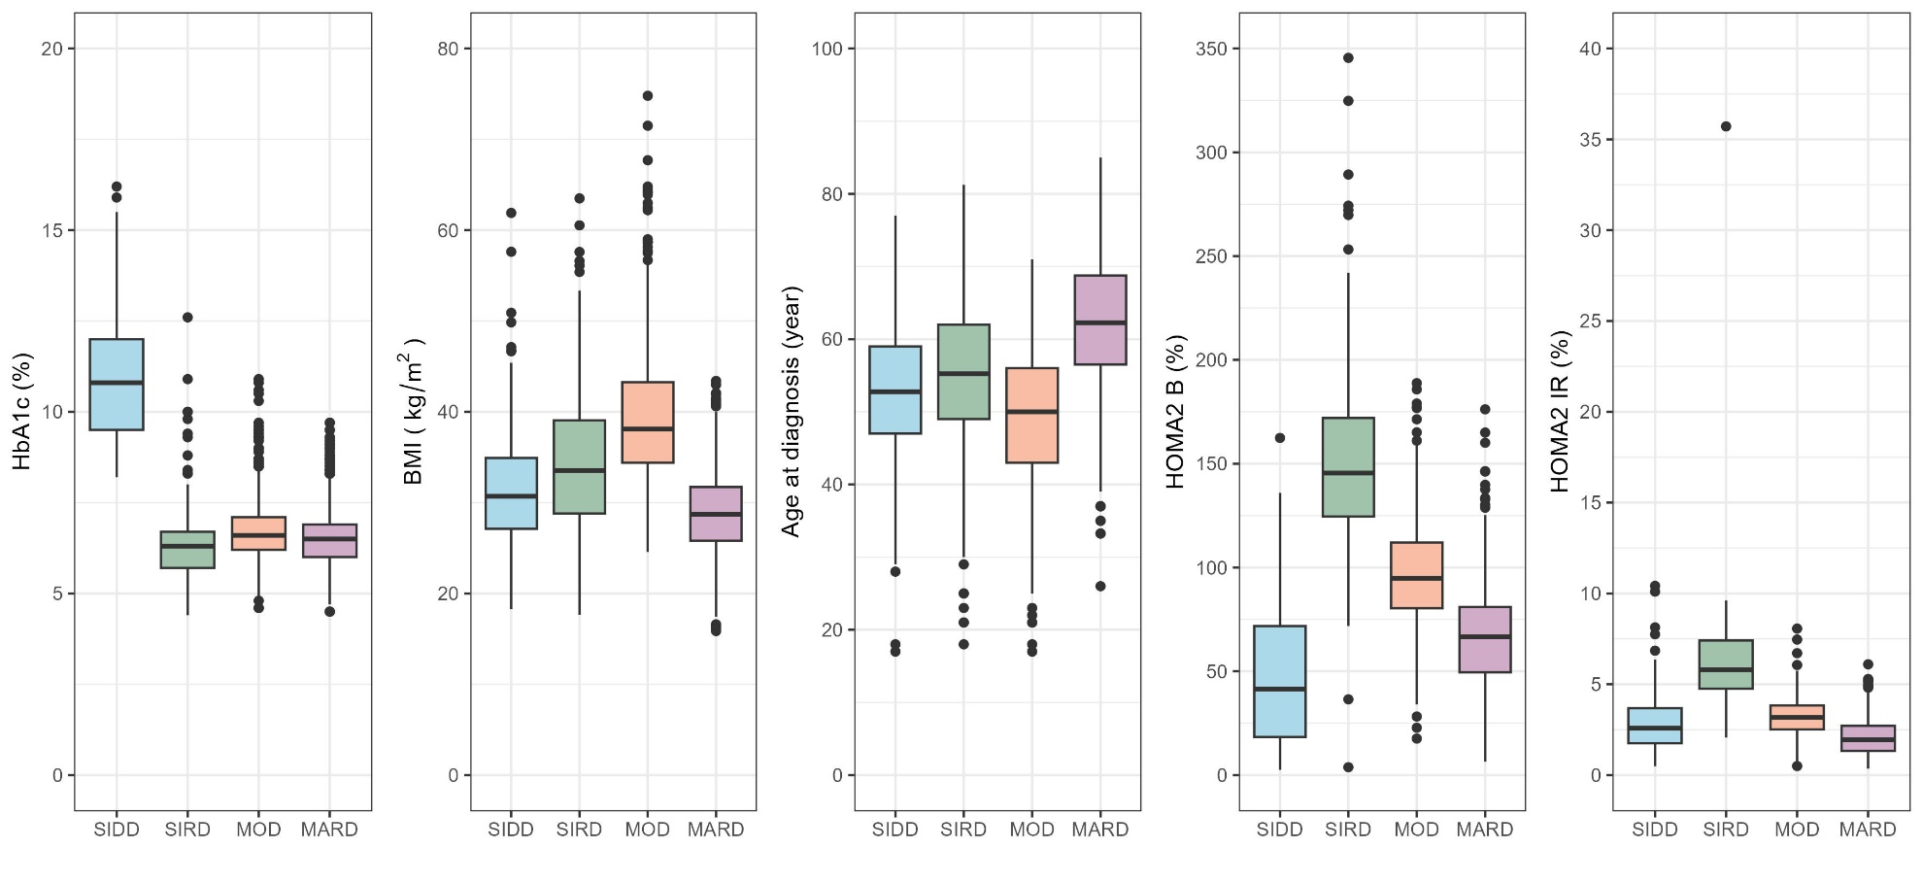
MARD = Mild Age-Related Diabetes, MOD = Mild Obesity-Related Diabetes, SIDD = Severe Insulin-Deficient Diabetes, SIRD = Severe Insulin-Resistant Diabetes, NH = Non-Hispanic.

Figure 2. Cumulative incidence of all-cause and cause-specific mortality.
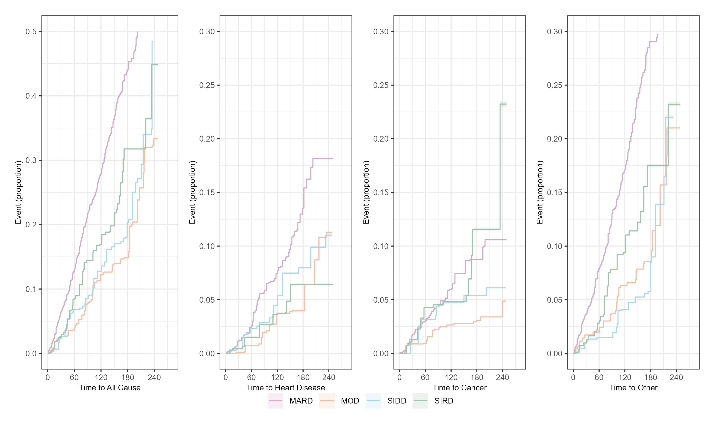
MARD = Mild Age-Related Diabetes, MOD = Mild Obesity-Related Diabetes, SIDD = Severe Insulin-Deficient Diabetes, SIRD = Severe Insulin-Resistant Diabetes. Estimates are from unadjusted Kaplan-Meier curves for mortality, censored as of December 2019.
Supplementary Table 1. Missing observations per variable.
Variable | Overall | MARD | MOD | SIDD | SIRD
Unweighted N | 2,440 | 1,281 | 623 | 258 | 278
Gender | 0 | 0 | 0 | 0 | 0
Race & Ethnicity | 0 | 0 | 0 | 0 | 0
Insurance Type | 3 | 2 | 0 | 0 | 1
Household Income ($) | 86 | 45 | 13 | 15 | 13
Age (years) | 0 | 0 | 0 | 0 | 0
Body Mass Index (kg/m²) | 0 | 0 | 0 | 0 | 0
Body Fat Percentage (%)ª | 743 | 478 | 141 | 39 | 85
Waist Circumference (cm) | 0 | 0 | 0 | 0 | 0
HbA1c (%) | 0 | 0 | 0 | 0 | 0
Fasting Glucose (mg/dL) | 1,007 | 499 | 320 | 122 | 66
Fasting Insulin (μU/mL) | 1,034 | 511 | 326 | 126 | 71
LDL (mg/dL) | 0 | 0 | 0 | 0 | 0
HDL (mg/dL) | 0 | 0 | 0 | 0 | 0
SBP (mmHg) | 0 | 0 | 0 | 0 | 0
DBP (mmHg) | 0 | 0 | 0 | 0 | 0
Triglycerides (mg/dL) | 0 | 0 | 0 | 0 | 0
eGFR (mL/min/1.73 m²) | 0 | 0 | 0 | 0 | 0
ALT (U/L) | 0 | 0 | 0 | 0 | 0
AST (U/L) | 0 | 0 | 0 | 0 | 0
ª Only available in 2011-2018. MARD = Mild Age-Related Diabetes, MOD = Mild Obesity-Related Diabetes, SIDD = Severe Insulin-Deficient Diabetes, SIRD = Severe Insulin Resistant Diabetes.

Supplementary Table 2. Unweighted characteristics of overall sample and by cluster.
Variable | Overall | MARD | MOD | SIDD | SIRD | Excluded for missing BMI or HbA1c
Unweighted N | 2,440 | 1,281 | 623 | 258 | 278 | 97
Gender
- Male | 53.1% (51.1, 55.1) | 55.1 (52.4, 57.8) | 41.7 (37.9, 45.6) | 61.6 (55.7, 67.6) | 61.2 (55.4, 66.9) | 49.5 (39.5, 59.4)
- Female | 46.9 (44.9, 48.9) | 44.9 (42.2, 47.6) | 58.3 (54.4, 62.1) | 38.4 (32.4, 44.3) | 38.8 (33.1, 44.6) | 50.5 (40.6, 60.5)
Race & Ethnicity
- NH White | 34.3 (32.4, 36.2) | 39.3 (36.7, 42.0) | 29.4 (25.8, 33.0) | 21.7 (16.7, 26.7) | 33.8 (28.3, 39.4) | 36.1 (26.5, 45.6)
- NH Black | 24.5 (22.8, 26.3) | 21.5 (19.2, 23.7) | 31.1 (27.5, 34.8) | 21.3 (16.3, 26.3) | 27.0 (21.8, 32.2) | 27.8 (18.9, 36.8)
- Hispanic | 31.1 (29.3, 33.0) | 27.7 (25.3, 30.2) | 32.3 (28.6, 35.9) | 44.6 (38.5, 50.6) | 32.0 (26.5, 37.5) | 27.8 (18.9, 36.8)
- Other Race | 10 (8.8, 11.2) | 11.5 (9.7, 13.2) | 7.2 (5.2, 9.3) | 12.4 (8.4, 16.4) | 7.2 (4.2, 10.2) | 8.2 (2.8, 13.7)
Insurance Type
- Insured | 79.6 (78.0, 81.2) | 84.2 (82.2, 86.2) | 76.7 (73.4, 80.0) | 60.5 (54.5, 66.4) | 82.4 (77.9, 86.9) | 90.7 (84.9, 96.5)
- Uninsured | 20.2 (18.6, 21.8) | 15.5 (13.5, 17.4) | 23.1 (19.8, 26.4) | 39.5 (33.6, 45.5) | 17.3 (12.8, 21.7) | 8.2 (2.8, 13.7)
Household Income ($)
- Household Income Under 20k | 25.9 (24.1, 27.6) | 26.7 (24.3, 29.1) | 25.8 (22.4, 29.3) | 24 (18.8, 29.2) | 23.7 (18.7, 28.7) | 36.1 (26.5, 45.6)
- Household Income 20k to 45k | 32 (30.2, 33.9) | 31.3 (28.8, 33.8) | 33.2 (29.5, 36.9) | 36.8 (30.9, 42.7) | 28.1 (22.8, 33.3) | 36.1 (26.5, 45.6)
- Household Income 45k to 75k | 16.1 (14.6, 17.6) | 16.2 (14.2, 18.3) | 16.2 (13.3, 19.1) | 11.6 (7.7, 15.5) | 19.4 (14.8, 24.1) | 7.2 (2.1, 12.4)
- Household Income Over 75k | 16.9 (15.4, 18.4) | 16.7 (14.7, 18.7) | 18.1 (15.1, 21.2) | 12.4 (8.4, 16.4) | 19.1 (14.4, 23.7) | 9.3 (3.5, 15.1)
- Other | 5.6 (4.7, 6.5) | 5.5 (4.3, 6.8) | 4.5 (2.9, 6.1) | 9.3 (5.8, 12.8) | 5.0 (2.5, 7.6) | 7.2 (2.1, 12.4)
Age (years) | 58.1 (57.5, 58.7) [15.2] | 64.8 (64.1, 65.5) [12.8] | 50.1 (49.1, 51.1) [13.0] | 51.1 (49.5, 52.7) [13.0] | 51.8 (49.8, 53.9) [17.3] | 62.1 (58.5, 65.6) [17.8]
Body Mass Index (kg/m²) | 32.6 (32.3, 32.9) [7.6] | 28.9 (28.6, 29.1) [4.5] | 39.7 (39.1, 40.2) [7.5] | 31.7 (30.9, 32.5) [6.7] | 34.4 (33.4, 35.3) [8.0] | 32.2 (29.2, 35.3) [8.4]
Body Fat Percentage (%)ª | 37.3 (36.9, 37.6) [8.0] | 35.3 (34.8, 35.9) [7.6] | 41.4 (40.7, 42.0) [7.3] | 35.4 (34.4, 36.5) [7.7] | 36.9 (35.8, 38.1) [8.1] | 37.3 (34.7, 39.8) [8.2]
Waist Circumference (cm) | 108.7 (108.1, 109.3) [15.9] | 101.9 (101.3, 102.5) [11.4] | 121.6 (120.4, 122.7) [14.7] | 106.9 (105.1, 108.8) [15.1] | 113.0 (110.9, 115.1) [17.5] | 107.9 (102.0, 113.9) [19.4]
HbA1c (%) | 7.0 (7.0, 7.1) [1.7] | 6.5 (6.5, 6.6) [0.8] | 6.7 (6.7, 6.8) [0.9] | 10.9 (10.7, 11.1) [1.7] | 6.3 (6.2, 6.5) [1.0] | 6.8 (6.4, 7.2) [1.7]
Fasting Glucose (mg/dL) | 148.7 (146.1, 151.4) [51.3] | 135.9 (134.1, 137.7) [25.6] | 133.9 (131.0, 136.9) [26.2] | 266.5 (255.2, 277.8) [67.3] | 141.5 (136.1, 146.9) [40.2] | 147.5 (135.3, 159.6) [40.1]
HOMA2-B | 81.4 (79.8, 83.0) [40.0] | 66.1 (64.9, 67.4) [23.4] | 96.1 (94.1, 98.0) [24.9] | 47.2 (43.2, 51.2) [32.8] | 150.3 (145.4, 155.2) [41.7] | 85.0 (69.9, 100.2) [48.9]
HOMA2-IR | 2.9 (2.8, 3.0) [1.8] | 2.1 (2.0, 2.1) [1.0] | 3.2 (3.1, 3.3) [1.0] | 2.8 (2.7, 3.0) [1.6] | 6.0 (5.8, 6.3) [2.3] | 3.4 (2.6, 4.2) [2.6]
LDL (mg/dL) | 114.3 (113.1, 115.6) [30.8] | 113.1 (111.4, 114.8) [31.5] | 115.7 (113.6, 117.8) [27.3] | 125.3 (121.1, 129.4) [33.7] | 106.9 (103.4, 110.4) [29.8] | 108.0 (96.7, 119.4) [34.7]
HDL (mg/dL) | 46.4 (46.0, 46.8) [10.0] | 48.3 (47.8, 48.9) [10.4] | 45.0 (44.3, 45.7) [8.5] | 43.2 (42.2, 44.1) [7.9] | 44.0 (42.7, 45.2) [10.7] | 46.6 (42.9, 50.2) [10.9]
SBP (mmHg) | 132.0 (131.2, 132.8) [19.4] | 133.9 (132.8, 135.0) [20.1] | 129.4 (128.0, 130.8) [18.0] | 130.6 (128.1, 133.1) [20.6] | 130.3 (128.3, 132.4) [17.4] | 135.7 (130.5, 140.9) [23.5]
DBP (mmHg) | 72.3 (71.8, 72.8) [12.7] | 70.2 (69.5, 70.9) [12.4] | 75.2 (74.2, 76.2) [12.6] | 73.7 (72.2, 75.3) [12.8] | 73.9 (72.4, 75.4) [12.4] | 70.2 (67.3, 73.1) [13.1]
Triglycerides (mg/dL) | 185.4 (180.5, 190.4) [124.8] | 178.4 (171.6, 185.3) [125.2] | 174.6 (167.0, 182.1) [96.2] | 230.2 (211.2, 249.3) [156.1] | 200.5 (184.4, 216.6) [137.0] | 164.8 (137.0, 192.6) [82.8]
eGFR (mL/min/1.73 m²) | 88.8 (87.9, 89.8) [24.2] | 79.9 (78.7, 81.2) [22.5] | 98.3 (96.7, 100.0) [20.8] | 104.8 (102.2, 107.3) [20.7] | 93.9 (90.9, 96.8) [25.2] | 84.1 (76.7, 91.4) [28.6]
ALT (U/L) | 30.5 (29.5, 31.6) [26.5] | 26.1 (25.2, 27.1) [17.4] | 32.9 (30.8, 34.9) [26.6] | 37.6 (32.6, 42.6) [41.3] | 38.8 (34.4, 43.2) [37.2] | 25.6 (21.2, 29.9) [16.8]
AST (U/L) | 28.2 (27.3, 29.2) [24.2] | 26.3 (25.5, 27.1) [14.6] | 29.2 (26.4, 32.0) [35.9] | 30.5 (27.1, 33.9) [27.9] | 32.7 (30.1, 35.4) [22.4] | 26.0 (22.1, 29.9) [15.0]
ª Only available in 2011-2018. MARD = Mild Age-Related Diabetes, MOD = Mild Obesity-Related Diabetes, SIDD = Severe Insulin-Deficient Diabetes, SIRD = Severe Insulin-Resistant Diabetes, NH = Non-Hispanic. All estimates are mean (95% CI) [standard deviation] and proportion (95% CI).
Supplementary Table 3. Sensitivity analysis results
Year Removed | Sample Size | Adjusted RAND Index
1999-2000 | 174 | 0.99
2001-2002 | 188 | 0.95
2003-2004 | 185 | 0.97
2005-2006 | 175 | 0.47
2007-2008 | 318 | 0.49
2009-2010 | 318 | 0.97
2011-2012 | 271 | 0.95
2013-2014 | 233 | 0.94
2015-2016 | 294 | 0.98
2017-2018 | 284 | 0.94
The lower ARI for some rounds may reflect underlying differences in distribution of clinical characteristics (Supplementary Figure 2)
Supplementary Table 4. Body composition distribution for subtypes of type 2 diabetes
Variable | Overall | MARD | MOD | SIDD | SIRD
Unweighted N | 2,440 | 1,281 | 623 | 258 | 278
Body Mass Index (kg/m²) | 33.4 (33.0, 33.9) [7.8] | 29.3 (28.9, 29.6) [4.6] | 39.6 (38.7, 40.4) [7.4] | 32.5 (31.2, 33.9) [6.7] | 36.0 (34.1, 37.9) [9.2]
Body Fat Percentage (%)ª | 37.3 (36.7, 37.8) [8.0] | 35.0 (34.3, 35.6) [7.5] | 41.2 (40.3, 42.1) [7.3] | 34.7 (33.3, 36.1) [7.6] | 37.0 (35.5, 38.5) [7.8]
Waist Circumference (cm) | 111.2 (110.2, 112.2) [16.6] | 102.9 (101.9, 103.9) [11.8] | 122.8 (121.2, 124.4) [14.6] | 109.8 (106.4, 113.1) [15.6] | 116.8 (112.9, 120.7) [19.1]
% Arm + Leg Fat (subcutaneous fat proxy)ª | 36.6 (35.8, 37.3) [9.8] | 34.1 (33, 35.2) [9.5] | 40.9 (39.5, 42.3) [9] | 33.8 (31.7, 35.8) [9.5] | 35.6 (33.4, 37.7) [8.7]
% Trunk Fat (central fat)ª | 38.0 (37.4, 38.6) [7.8] | 35.1 (34.2, 35.9) [7.3] | 42.2 (41.2, 43.3) [6.7] | 36.3 (34.7, 37.9) [7.6] | 38.4 (36.6, 40.2) [7.2]
Trunk to limb Fat Ratio (Trunk [kg]/[Arm [kg] + Leg[kg]])ª | 0.265 (0.262, 0.268) [0.038] | 0.266 (0.262, 0.271) [0.040] | 0.260 (0.255, 0.264) [0.031] | 0.271 (0.261, 0.280) [0.040] | 0.271 (0.260, 0.282) [0.040]
Fat Mass Index (total fat mass [kg] /height²)ª | 12.9 (12.5, 13.4) [5.3] | 10.2 (9.8, 10.5) [3.2] | 16.6 (15.7, 17.4) [5.3] | 11.6 (10.7, 12.5) [4.5] | 13.5 (12.1, 14.9) [5.1]
Leg to trunk lean mass ratioª | 0.633 (0.628, 0.638) [0.066] | 0.626 (0.619, 0.634) [0.061] | 0.642 (0.633, 0.651) [0.067] | 0.626 (0.609, 0.642) [0.068] | 0.639 (0.621, 0.658) [0.075]
Total Lean Mass (kg)ª | 60.8 (59.5, 62) [14.5] | 54.4 (53.1, 55.8) [11.3] | 66.3 (64, 68.6) [14.6] | 60.6 (56.6, 64.6) [13.9] | 66.9 (62, 71.8) [15.6]
Lean Mass Index (Total Lean mass[kg]/ Height²)ª | 21.1 (20.8, 21.5) [3.7] | 19 (18.7, 19.3) [2.6] | 23.2 (22.6, 23.8) [3.6] | 21.1 (20.1, 22) [3.4] | 22.4 (21.1, 23.7) [4]
ª Because Whole Body Dual-Energy X-ray Absorptiometry scans were not performed during the 2007-2008 and 2009-2010 waves, the marked variables were unavailable or unable to be computed for these cycles. All estimates are mean (95% CI)[standard deviation] and proportion (95% CI) accounting for the complex multi-stage survey design.

Supplementary Table 5. Rates of all-cause and cause-specific mortality for subtypes of type 2 diabetes ignoring survey design
 |  |  | Unadjusted |  |  | Adjusted
Outcome | Events | MARD | MOD | SIDD | SIRD | MOD | SIDD | SIRD
Overall
All Cause | 578 | Ref | 0.33  (0.26, 0.42) | 0.51  (0.38, 0.68) | 0.53  (0.40, 0.71) | 0.98  (0.74, 1.29) | 1.02  (0.75, 1.38) | 0.84  (0.63, 1.13)
Cause-Specific Hazards
Cardiovascular | 140 | Ref | 0.33  (0.20, 0.54) | 0.81  (0.49, 1.32) | 0.44  (0.23, 0.84) | 1.2  (0.68, 2.12) | 1.81  (1.07, 3.07) | 0.75  (0.39, 1.46)
Cancer | 119 | Ref | 0.5  (0.31, 0.82) | 0.51  (0.25, 1.01) | 0.92  (0.53, 1.58) | 0.89  (0.51, 1.56) | 0.72  (0.35, 1.48) | 1.17  (0.67, 2.04)
Other | 319 | Ref | 0.28  (0.2, 0.39) | 0.39  (0.25, 0.59) | 0.45  (0.3, 0.68) | 0.92  (0.63, 1.35) | 0.84  (0.54, 1.31) | 0.75  (0.5, 1.13)
5-Year
All Cause | 226 | Ref | 0.3  (0.22, 0.4) | 0.47  (0.33, 0.67) | 0.51  (0.36, 0.72) | 0.96  (0.68, 1.34) | 1.03  (0.70, 1.49) | 0.87  (0.61, 1.24)
Cause-Specific Hazards
Cardiovascular | 49 | Ref | 0.32  (0.17, 0.59) | 0.88  (0.50, 1.57) | 0.44  (0.2, 0.96) | 1.37  (0.68, 2.76) | 2.36  (1.27, 4.39) | 0.88  (0.4, 1.95)
Cancer | 55 | Ref | 0.44  (0.25, 0.78) | 0.49  (0.23, 1.08) | 0.76  (0.4, 1.45) | 0.76  (0.4, 1.45) | 0.70  (0.31, 1.57) | 0.97  (0.5, 1.88)
Other | 122 | Ref | 0.24  (0.16, 0.37) | 0.3  (0.17, 0.54) | 0.44  (0.27, 0.72) | 0.9  (0.55, 1.46) | 0.73  (0.4, 1.33) | 0.82  (0.5, 1.35)
10-Year
All Cause | 422 | Ref | 0.24  (0.15, 0.38) | 0.58  (0.36, 0.92) | 0.64  (0.41, 0.99) | 0.78  (0.47, 1.3) | 1.23  (0.76, 2.01) | 1.10  (0.7, 1.73)
Cause-Specific Hazards
Cardiovascular | 101 | Ref | 0.25  (0.09, 0.71) | 1.51  (0.74, 3.08) | 0.58  (0.21, 1.65) | 1.52  (0.48, 4.84) | 4.67  (2.13, 10.27) | 1.36  (0.47, 3.96)
Cancer | 95 | Ref | 0.32  (0.13, 0.76) | 0.38  (0.12, 1.24) | 1.1  (0.53, 2.28) | 0.53  (0.2, 1.37) | 0.52  (0.15, 1.74) | 1.36  (0.64, 2.9)
Other | 226 | Ref | 0.21  (0.11, 0.39) | 0.35  (0.16, 0.75) | 0.48  (0.25, 0.91) | 0.73  (0.36, 1.5) | 0.80  (0.36, 1.77) | 0.86  (0.44, 1.68)
Analysis was based on 2,440 individuals with median follow-up of 97 months (IQR: 49-145). MARD = Mild Age-Related Diabetes, MOD = Mild Obesity-Related Diabetes, SIDD = Severe Insulin-Deficient Diabetes, SIRD = Severe Insulin-Resistant Diabetes. All associations are hazard ratios, adjusting for age-, sex-, smoking (current or former), and decade period effects. All estimates are mean (95% CI).
Supplementary Table 6. Rates of all-cause and cause-specific mortality for subtypes of all type 2 diabetes
 |  |  | Unadjusted |  |  | Adjusted
Outcome | Events | MARD | Mild Diabetes | SIDD | SIRD | Mild Diabetes | SIDD | SIRD
Overall
All Cause | 2042 | Ref | 0.39  (0.34, 0.44) | 0.5  (0.42, 0.58) | 0.6  (0.53, 0.67) | 0.97  (0.82, 1.15) | 0.93  (0.78, 1.11) | 1.04  (0.91, 1.18)
Cause-Specific Hazards
Cardiovascular | 573 | Ref | 0.4  (0.32, 0.51) | 0.49  (0.36, 0.66) | 0.61  (0.49, 0.75) | 1.03  (0.75, 1.42) | 0.94  (0.67, 1.32) | 1.06  (0.83, 1.36)
Cancer | 354 | Ref | 0.29  (0.21, 0.4) | 0.43  (0.29, 0.64) | 0.48  (0.36, 0.64) | 0.82  (0.53, 1.27) | 0.94  (0.6, 1.46) | 0.94  (0.68, 1.3)
Other | 1115 | Ref | 0.41  (0.35, 0.49) | 0.52  (0.42, 0.65) | 0.64  (0.55, 0.75) | 0.99  (0.79, 1.25) | 0.93  (0.73, 1.18) | 1.06  (0.89, 1.27)
5-Year
All Cause | 826 | Ref | 0.39  (0.34, 0.45) | 0.49  (0.41, 0.59) | 0.61  (0.53, 0.7) | 0.99  (0.81, 1.21) | 0.93  (0.75, 1.15) | 1.05  (0.9, 1.23)
Cause-Specific Hazards
Cardiovascular | 236 | Ref | 0.42  (0.32, 0.56) | 0.47  (0.32, 0.68) | 0.7  (0.54, 0.9) | 1.2  (0.82, 1.75) | 0.97  (0.63, 1.48) | 1.25  (0.94, 1.66)
Cancer | 161 | Ref | 0.3  (0.21, 0.42) | 0.48  (0.32, 0.73) | 0.44  (0.31, 0.61) | 0.98  (0.6, 1.59) | 1.16  (0.71, 1.87) | 0.93  (0.64, 1.34)
Other | 429 | Ref | 0.41  (0.34, 0.51) | 0.51  (0.39, 0.65) | 0.64  (0.53, 0.76) | 0.92  (0.7, 1.2) | 0.85  (0.63, 1.14) | 1  (0.81, 1.24)
10-Year
All Cause | 1539 | Ref | 0.39  (0.32, 0.48) | 0.53  (0.41, 0.68) | 0.62  (0.51, 0.74) | 0.92  (0.7, 1.2) | 0.89  (0.67, 1.19) | 0.99  (0.81, 1.23)
Cause-Specific Hazards
Cardiovascular | 425 | Ref | 0.48  (0.33, 0.69) | 0.57  (0.35, 0.93) | 0.58  (0.4, 0.84) | 1.03  (0.61, 1.72) | 0.87  (0.5, 1.53) | 0.9  (0.59, 1.37)
Cancer | 290 | Ref | 0.28  (0.17, 0.46) | 0.54  (0.32, 0.91) | 0.48  (0.32, 0.73) | 1.11  (0.59, 2.11) | 1.43  (0.78, 2.62) | 1.11  (0.7, 1.78)
Other | 824 | Ref | 0.4  (0.3, 0.53) | 0.51  (0.36, 0.72) | 0.69  (0.54, 0.88) | 0.81  (0.56, 1.17) | 0.76  (0.5, 1.13) | 0.99  (0.75, 1.32)
Analysis was based on 7,498 individuals with median follow-up of 87 months (IQR: 45-138). MARD = Mild Age-Related Diabetes, SIDD = Severe Insulin-Deficient Diabetes, SIRD = Severe Insulin-Resistant Diabetes. We did not identify a cluster resembling Mild Obesity Diabetes. All associations are hazard ratios, adjusting for age-, sex-, smoking (current or former), period effects, medication use (insulin, other glucose lowering meds, antihypertensives, cholesterol lowering meds), and duration. All estimates are mean (95% CI).

Supplementary Table 7. Rates of all-cause and cause-specific mortality for subtypes of type 2 diabetes relative to adults 40 or older without T2D at time of survey
Outcome | Events | No T2D | MARD | MOD | SIDD | SIRD | MARD | MOD | SIDD | SIRD
Overall
All Cause | 6181 | Ref | 2.32 (2.04, 2.64) | 0.86 (0.68, 1.1) | 1.19 (0.86, 1.66) | 1.7 (1.49, 1.93) | 2.61 (2.05, 3.32) | 1.98 (1.42, 2.76) | 1.69 (1.23, 2.31) | 1.7 (1.49, 1.93)
Cause-Specific Hazards
Cardiovascular | 1554 | Ref | 2.4 (1.85, 3.1) | 0.95 (0.6, 1.51) | 1.39 (0.74, 2.6) | 1.83 (1.41, 2.37) | 3.86 (2.4, 6.19) | 2.76 (1.47, 5.2) | 1.43 (0.68, 3.01) | 1.83 (1.41, 2.37)
Cancer | 1501 | Ref | 1.58 (1.17, 2.12) | 0.59 (0.34, 1.03) | 1.02 (0.51, 2.06) | 1.12 (0.83, 1.5) | 1.26 (0.72, 2.2) | 1.35 (0.67, 2.72) | 1.68 (0.96, 2.94) | 1.12 (0.83, 1.5)
Other | 3125 | Ref | 2.69 (2.27, 3.18) | 0.97 (0.71, 1.33) | 1.19 (0.74, 1.9) | 2.01 (1.69, 2.38) | 3.18 (2.3, 4.39) | 2.08 (1.3, 3.34) | 1.83 (1.18, 2.85) | 2.01 (1.69, 2.38)
5-Year
All Cause | 4363 | Ref | 2.32 (2, 2.69) | 0.88 (0.66, 1.16) | 0.95 (0.61, 1.5) | 1.74 (1.5, 2.02) | 2.81 (2.12, 3.74) | 1.77 (1.13, 2.78) | 1.7 (1.17, 2.48) | 1.74 (1.5, 2.02)
Cause-Specific Hazards
Cardiovascular | 1101 | Ref | 2.26 (1.66, 3.08) | 0.96 (0.55, 1.67) | 1.32 (0.6, 2.9) | 1.78 (1.31, 2.43) | 4.47 (2.54, 7.85) | 3.14 (1.42, 6.96) | 1.68 (0.72, 3.94) | 1.78 (1.31, 2.43)
Cancer | 1125 | Ref | 1.63 (1.17, 2.27) | 0.72 (0.4, 1.29) | 1.31 (0.63, 2.71) | 1.19 (0.85, 1.65) | 1.62 (0.9, 2.91) | 1.86 (0.9, 3.86) | 1.52 (0.77, 3.03) | 1.19 (0.85, 1.65)
Other | 2136 | Ref | 2.74 (2.25, 3.34) | 0.93 (0.63, 1.37) | 0.57 (0.25, 1.32) | 2.09 (1.71, 2.55) | 3.21 (2.16, 4.79) | 1.14 (0.5, 2.64) | 1.87 (1.1, 3.19) | 2.09 (1.71, 2.55)
10-Year
All Cause | 2284 | Ref | 2.34 (1.91, 2.85) | 0.69 (0.44, 1.07) | 1.17 (0.66, 2.07) | 1.87 (1.53, 2.28) | 2.28 (1.46, 3.58) | 2.23 (1.25, 3.98) | 1.9 (1.15, 3.12) | 1.87 (1.53, 2.28)
Cause-Specific Hazards
Cardiovascular | 608 | Ref | 1.63 (1.02, 2.6) | 0.48 (0.17, 1.37) | 1.49 (0.55, 4.09) | 1.36 (0.85, 2.18) | 2.61 (0.9, 7.56) | 3.86 (1.4, 10.67) | 1.54 (0.48, 5.02) | 1.36 (0.85, 2.18)
Cancer | 611 | Ref | 1.87 (1.23, 2.84) | 0.61 (0.25, 1.48) | 1.85 (0.78, 4.39) | 1.46 (0.96, 2.21) | 1.51 (0.62, 3.69) | 2.82 (1.18, 6.72) | 2.8 (1.36, 5.77) | 1.46 (0.96, 2.21)
Other | 1065 | Ref | 3.01 (2.32, 3.91) | 0.85 (0.47, 1.52) | 0.57 (0.17, 1.91) | 2.43 (1.87, 3.16) | 2.76 (1.52, 5.02) | 1.12 (0.33, 3.75) | 1.45 (0.62, 3.39) | 2.43 (1.87, 3.16)
Analysis was based on 2,440 individuals with newly diagnosed T2D median follow-up of 97 months (IQR: 49-145) and 26,821 individuals without T2D. MARD = Mild Age-Related Diabetes, MOD = Mild Obesity-Related Diabetes, SIDD = Severe Insulin-Deficient Diabetes, SIRD = Severe Insulin-Resistant Diabetes. All associations are hazard ratios, adjusting for age-, sex-, smoking (current or former), and period effects. All estimates are mean (95% CI).

Supplementary Figure 1. Flowchart of analytic sample.
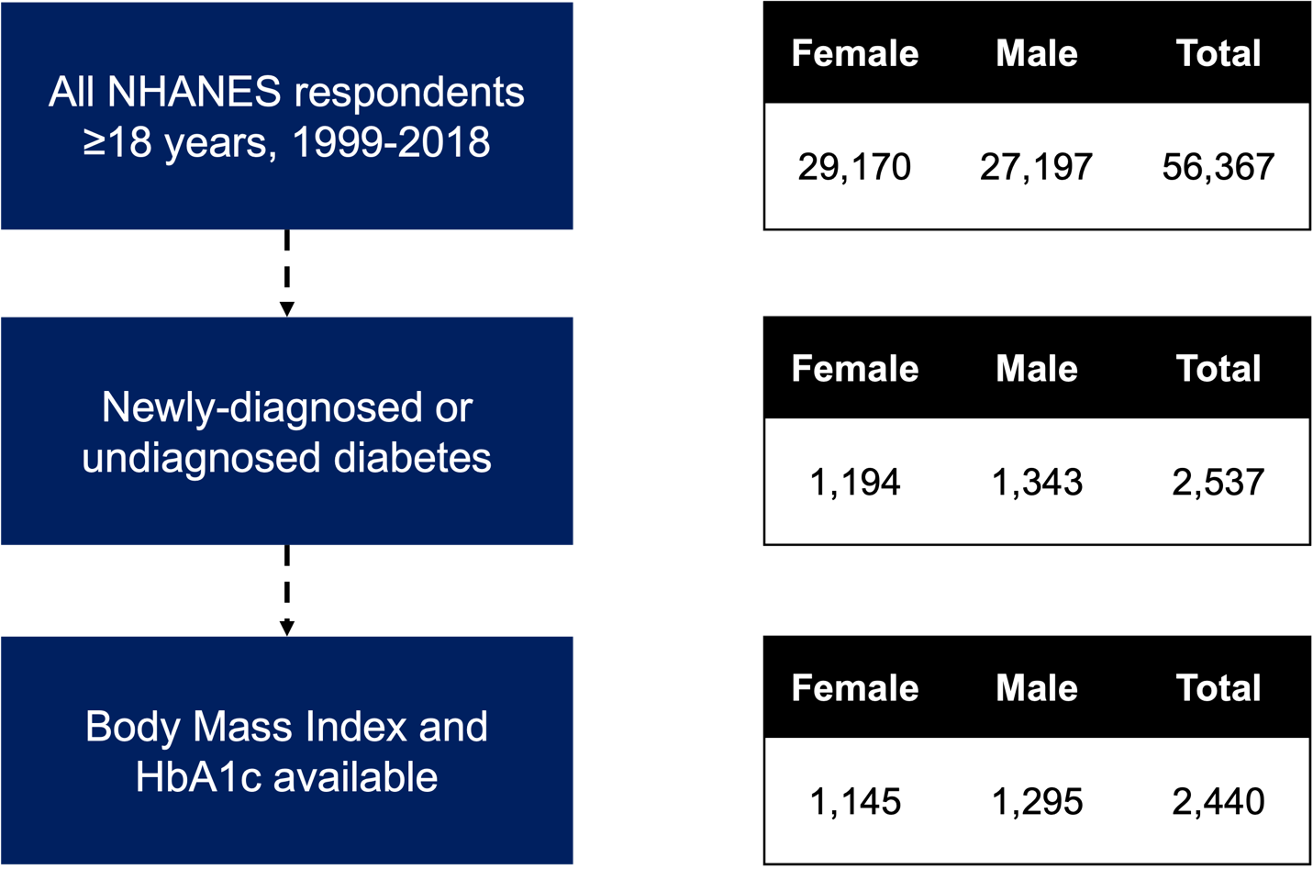

Supplementary Figure 2. Elbow plot
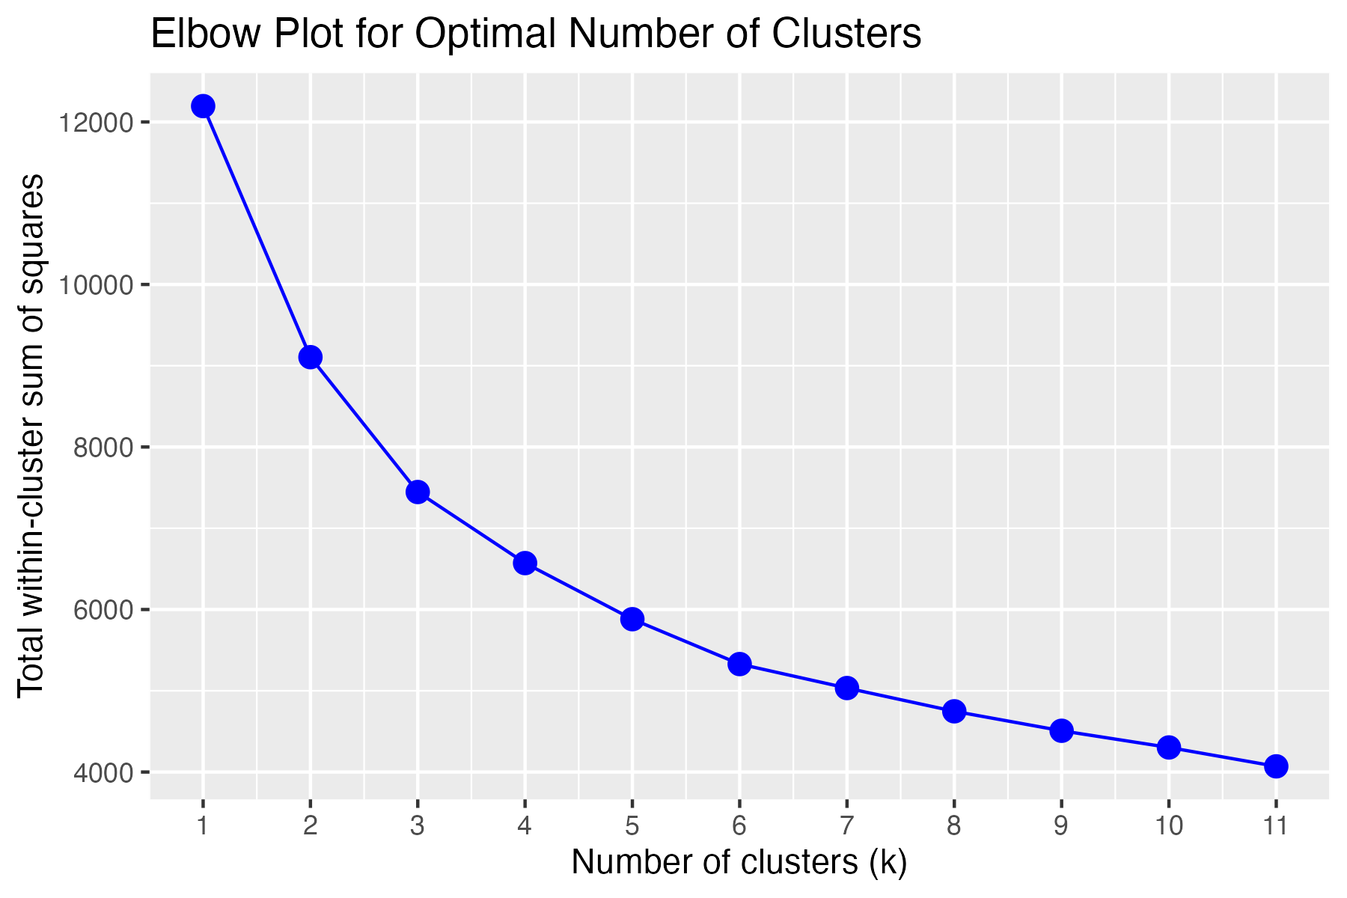
We did not observe a clear number for optimal number of clusters from the Elbow plot.

Supplementary Figure 2. Distribution of clustering variables by survey round from 1999 to 2018
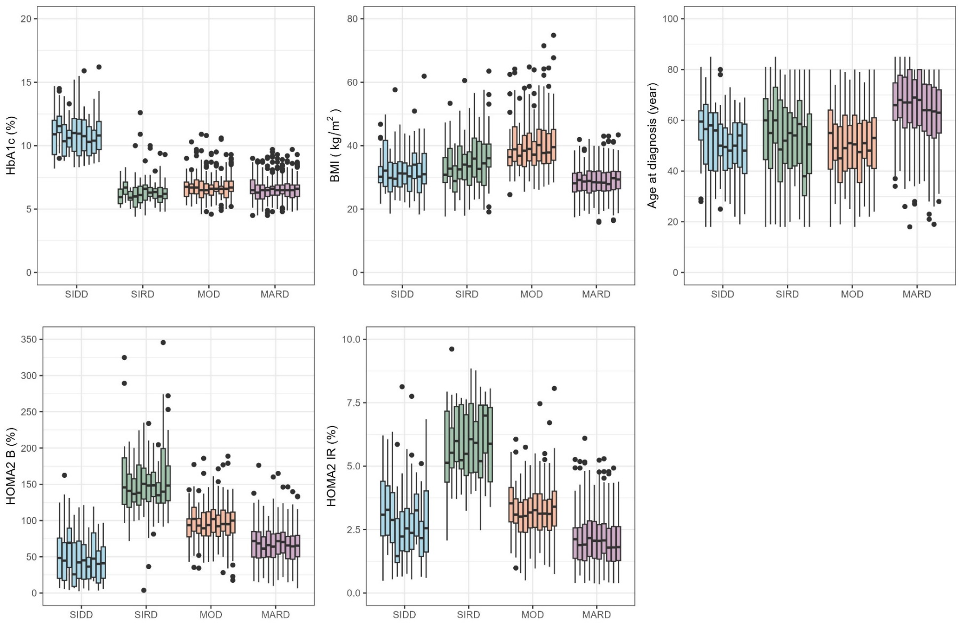

Supplementary Figure 3. Unadjusted cumulative hazards including adults over 40 years without type 2 diabetes
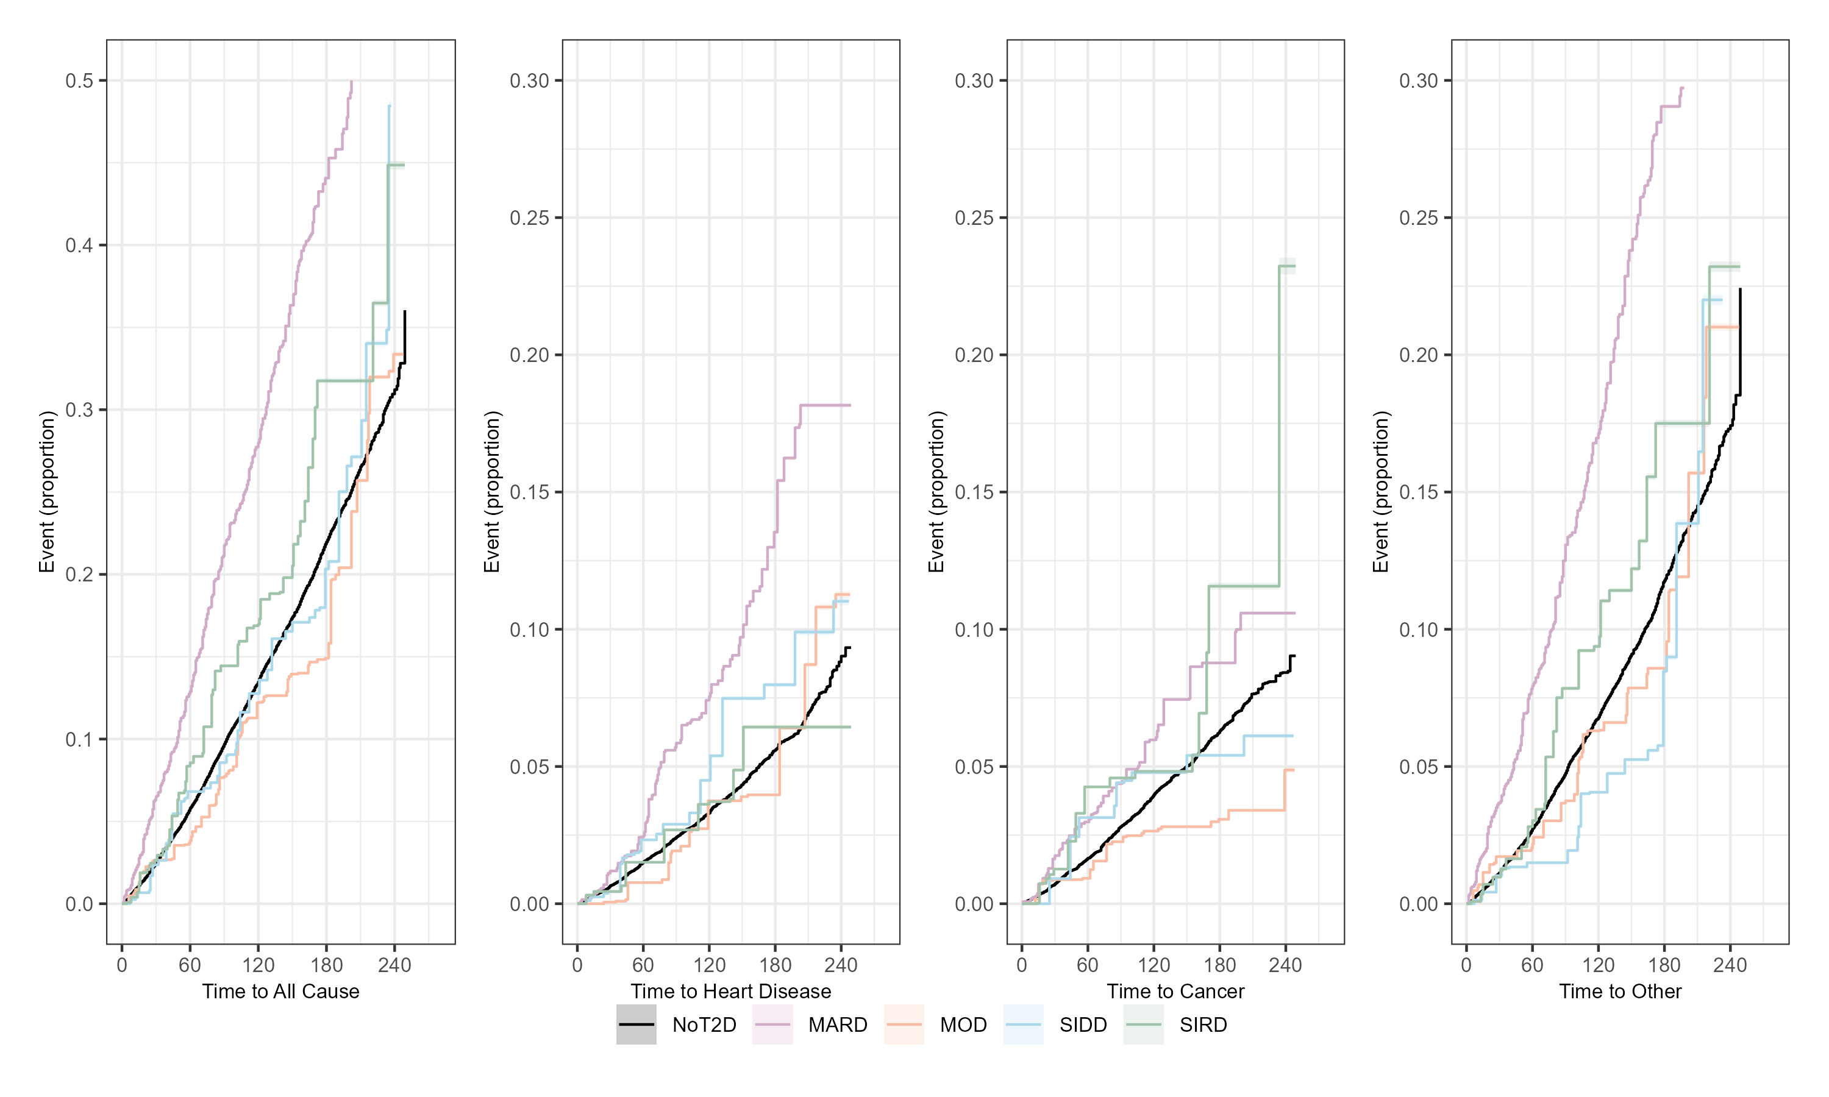
Reference population of individuals ≥40 years and newly diagnosed T2D subtypes plotted. Other causes include any explanation for mortality other than heart disease or cancer.

